Ripped Foil - Monkeys

Zeynep Civelek

June 30, 2020

## Exploring the data

The structure of the data is shown below with all the variable names and levels of measurement.

## 'data.frame': 608 obs. of 11 variables:  
## $ id : Factor w/ 19 levels "Alba","Bear",..: 15 15 15 15 15 15 15 15 15 15 ...  
## $ sex : Factor w/ 2 levels "f","m": 2 2 2 2 2 2 2 2 2 2 ...  
## $ age : int 8 8 8 8 8 8 8 8 8 8 ...  
## $ order : Factor w/ 2 levels "food-stick at test",..: 1 1 1 1 1 1 1 1 1 1 ...  
## $ boxtype : Factor w/ 2 levels "blue","pink": 1 1 1 1 1 1 1 1 1 1 ...  
## $ phase : Factor w/ 2 levels "test","transfer": 1 1 1 1 1 1 1 1 1 1 ...  
## $ sessionno: int 1 1 1 1 1 1 1 1 2 2 ...  
## $ trialno : int 1 2 3 4 5 6 7 8 9 10 ...  
## $ correct : int 1 1 1 1 1 1 1 1 1 1 ...  
## $ trialtype: Factor w/ 2 levels "food","stick": 1 1 1 1 1 1 1 1 1 1 ...  
## $ phase2 : Factor w/ 2 levels "1","2": 1 1 1 1 1 1 1 1 1 1 ...

## Histograms for Warm-up 1 and Warm-up 2 Phases

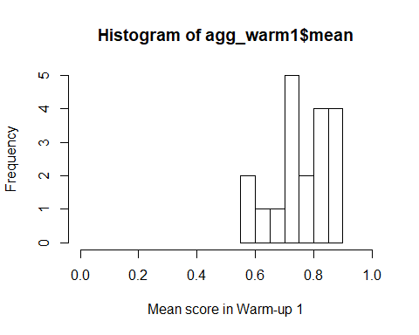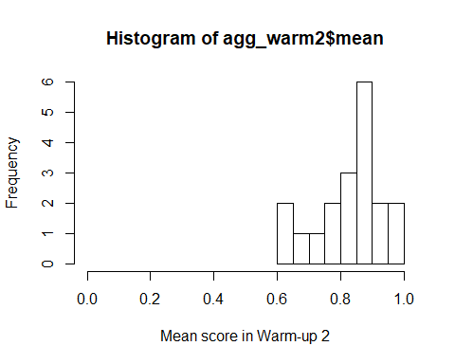

**In warm-up 1 (locating the reward when there is no foil covering the cups), monkeys got up to 18 sessions to reach criterion. In warm-up 2 (locating the reward when the cups were covered with foil), up to 6 sessions (or they'd receive up to 10 sessions). The minimum number of sessions to reach criterion was 2 (14/16 correct).**

I aggregated the trial-by-trial data to create one score per monkey for Test and Transfer phases so I can check whether or not they are normally distributed.

## Histograms for Test and Transfer Phases and the overall score

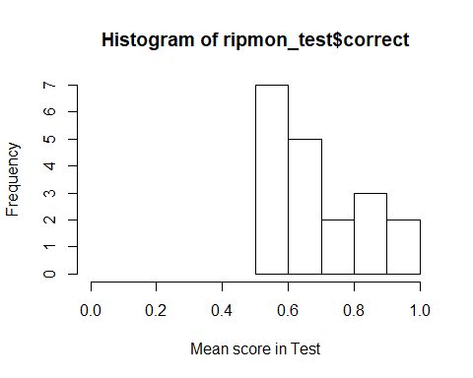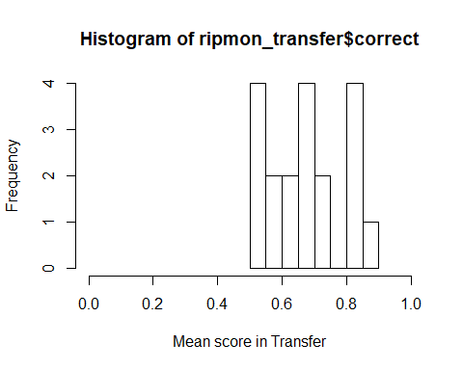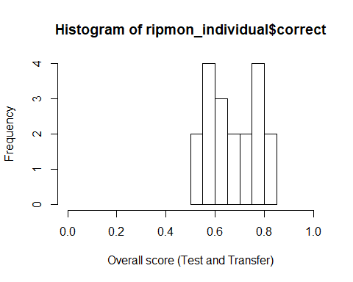

## The tests of normality for Test and Transfer phases as well as for the overall score

##   
## Shapiro-Wilk normality test  
##   
## data: ripmon_individual$correct  
## W = 0.93337, p-value = 0.1997

##   
## Shapiro-Wilk normality test  
##   
## data: ripmon_test$correct  
## W = 0.89976, p-value = 0.04817

##   
## Shapiro-Wilk normality test  
##   
## data: ripmon_transfer$correct  
## W = 0.91414, p-value = 0.08822

The Shapiro-Wilk normality tests show that the data are normally distributed for Test and Transfer phases (as well as the overall scores per individual).

## Below is how performance looks in the last 16 trials of Test and Transfer

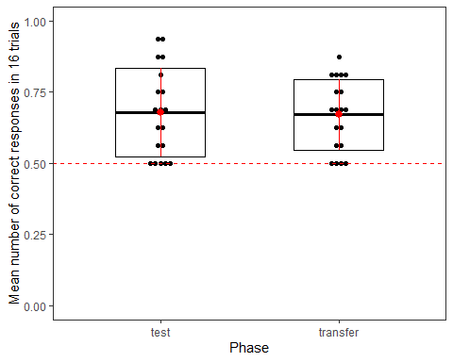

## Preparation of the data for running the GLMM

* Scaling age and trial number
* Coding categorical variables as dummy variables
* Centering the slopes.

## Full model

contr<-glmerControl(optimizer="bobyqa", optCtrl=list(maxfun=10000000))  
full=glmer(correct ~ trialtype*phase+z.trialno+z.age+sex+(1+z.trialno+phase.transfer.c+trialtype.food.c|id),data=ripmon1, family=binomial, control=contr)

The full model does not include box type (the location of the blue/pink box) as a random effect anymore due to convergence issues.

## Model assumptions

#### Distribution of random effects

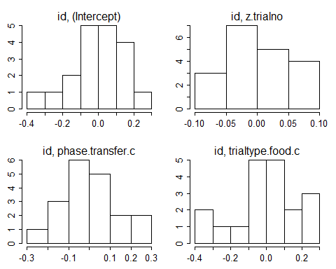

#### Model stability

## [1] "please carefully evaluate whether the result makes sense, and if not, please contact me"

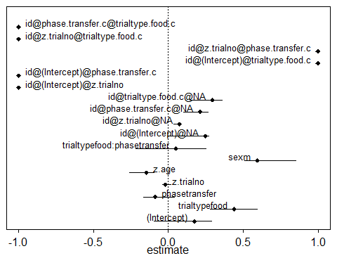

#### Multicollinearity

## trialtype phase z.trialno z.age sex   
## 2.082 2.082 1.000 1.031 1.100   
## trialtype:phase   
## 3.347

#### Overdispersion

## chisq df P dispersion.parameter  
## 1 586.9146 591 0.5397095 0.9930873

## Null model

null=glmer(correct~(1+z.trialno+phase.transfer.c+trialtype.food.c|id),data=ripmon1, family=binomial, control=contr)

**Question:** I have (1|id) as another random effect in the child model. Do I not need to include it here?

## Full and Null comparison

## Data: ripmon1  
## Models:  
## null: correct ~ (1 + z.trialno + phase.transfer.c + trialtype.food.c |   
## null: id)  
## full: correct ~ trialtype * phase + z.trialno + z.age + sex + (1 +   
## full: z.trialno + phase.transfer.c + trialtype.food.c | id)  
## npar AIC BIC logLik deviance Chisq Df Pr(>Chisq)   
## null 11 783.29 831.80 -380.64 761.29   
## full 17 781.50 856.47 -373.75 747.50 13.79 6 0.032 *  
## ---  
## Signif. codes: 0 '***' 0.001 '**' 0.01 '*' 0.05 '.' 0.1 ' ' 1

## Model output

#### Coefficients

## Estimate Std. Error z value Pr(>|z|)  
## (Intercept) 0.175 0.252 0.695 0.487  
## trialtypefood 0.441 0.318 1.386 0.166  
## phasetransfer -0.088 0.256 -0.345 0.730  
## z.trialno -0.019 0.091 -0.209 0.834  
## z.age -0.147 0.105 -1.395 0.163  
## sexm 0.594 0.225 2.646 0.008  
## trialtypefood:phasetransfer 0.051 0.437 0.117 0.907

#### Individual predictor: Likelihood tests

## Single term deletions  
##   
## Model:  
## correct ~ trialtype * phase + z.trialno + z.age + sex + (1 +   
## z.trialno + phase.transfer.c + trialtype.food.c | id)  
## npar AIC LRT Pr(Chi)   
## <none> 781.50   
## z.trialno 1 779.54 0.044 0.834   
## z.age 1 781.48 1.983 0.159   
## sex 1 785.61 6.115 0.013 *  
## trialtype:phase 1 779.51 0.014 0.907   
## ---  
## Signif. codes: 0 '***' 0.001 '**' 0.01 '*' 0.05 '.' 0.1 ' ' 1

#### Confidence intervals for the full model with the interaction

## orig X2.5. X97.5.  
## (Intercept) 0.175 -0.354 0.693  
## trialtypefood 0.441 -0.185 1.094  
## phasetransfer -0.088 -0.626 0.471  
## z.trialno -0.019 -0.193 0.156  
## z.age -0.147 -0.368 0.070  
## sexm 0.594 0.143 1.105  
## trialtypefood:phasetransfer 0.051 -0.878 0.933

**The interaction term is not significant so I will remove it from the model.**

## Reduced model without the interaction

## Full model 2

full2=glmer(correct ~ trialtype+phase+z.trialno+z.age+sex+(1+z.trialno+phase.transfer.c+trialtype.food.c|id),data=ripmon1, family=binomial, control=contr)  
summary(full2)

## Generalized linear mixed model fit by maximum likelihood (Laplace  
## Approximation) [glmerMod]  
## Family: binomial ( logit )  
## Formula: correct ~ trialtype + phase + z.trialno + z.age + sex + (1 +   
## z.trialno + phase.transfer.c + trialtype.food.c | id)  
## Data: ripmon1  
## Control: contr  
##   
## AIC BIC logLik deviance df.resid   
## 779.5 850.1 -373.8 747.5 592   
##   
## Scaled residuals:   
## Min 1Q Median 3Q Max   
## -2.2178 -1.1532 0.5580 0.7109 1.0935   
##   
## Random effects:  
## Groups Name Variance Std.Dev. Corr   
## id (Intercept) 0.061730 0.24845   
## z.trialno 0.005576 0.07467 -1.00   
## phase.transfer.c 0.045824 0.21407 -1.00 1.00   
## trialtype.food.c 0.087315 0.29549 1.00 -1.00 -1.00  
## Number of obs: 608, groups: id, 19  
##   
## Fixed effects:  
## Estimate Std. Error z value Pr(>|z|)   
## (Intercept) 0.15981 0.21571 0.741 0.45878   
## trialtypefood 0.46980 0.19769 2.376 0.01748 *   
## phasetransfer -0.06881 0.19266 -0.357 0.72099   
## z.trialno -0.01905 0.09091 -0.210 0.83402   
## z.age -0.14625 0.10521 -1.390 0.16450   
## sexm 0.60054 0.21852 2.748 0.00599 **  
## ---  
## Signif. codes: 0 '***' 0.001 '**' 0.01 '*' 0.05 '.' 0.1 ' ' 1  
##   
## Correlation of Fixed Effects:  
## (Intr) trltyp phstrn z.trln z.age   
## trialtypefd -0.228   
## phasetrnsfr -0.490 -0.184   
## z.trialno -0.052 -0.076 0.055   
## z.age 0.137 -0.036 0.004 -0.001   
## sexm -0.687 -0.017 0.071 0.006 -0.212  
## convergence code: 0  
## boundary (singular) fit: see ?isSingular

I get the following warning: convergence code: 0, boundary (singular) fit: see ?isSingular.

**The model summary show that there is a significant effect of sex and trial type.**

## Null model 2

null2<-glmer(correct~ (1+z.trialno+phase.transfer.c+trialtype.food.c|id),data=ripmon1, family=binomial, control=contr)

## Full and null model (2) comparion

## Data: ripmon1  
## Models:  
## null: correct ~ (1 + z.trialno + phase.transfer.c + trialtype.food.c |   
## null: id)  
## full2: correct ~ trialtype + phase + z.trialno + z.age + sex + (1 +   
## full2: z.trialno + phase.transfer.c + trialtype.food.c | id)  
## npar AIC BIC logLik deviance Chisq Df Pr(>Chisq)   
## null 11 783.29 831.80 -380.64 761.29   
## full2 16 779.51 850.08 -373.76 747.51 13.776 5 0.017 *  
## ---  
## Signif. codes: 0 '***' 0.001 '**' 0.01 '*' 0.05 '.' 0.1 ' ' 1

## Model output

#### Coefficients

## Estimate Std. Error z value Pr(>|z|)  
## (Intercept) 0.160 0.216 0.741 0.459  
## trialtypefood 0.470 0.198 2.376 0.017  
## phasetransfer -0.069 0.193 -0.357 0.721  
## z.trialno -0.019 0.091 -0.210 0.834  
## z.age -0.146 0.105 -1.390 0.165  
## sexm 0.601 0.219 2.748 0.006

#### Individual predictors : Likelihood ratio tests

## Single term deletions  
##   
## Model:  
## correct ~ trialtype + phase + z.trialno + z.age + sex + (1 +   
## z.trialno + phase.transfer.c + trialtype.food.c | id)  
## npar AIC LRT Pr(Chi)   
## <none> 779.51   
## trialtype 1 785.23 7.720 0.005 **  
## phase 1 780.11 2.593 0.107   
## z.trialno 1 777.56 0.044 0.834   
## z.age 1 779.48 1.970 0.160   
## sex 1 784.02 6.511 0.011 *   
## ---  
## Signif. codes: 0 '***' 0.001 '**' 0.01 '*' 0.05 '.' 0.1 ' ' 1

#### Confidence intervals for the reduced model without the interaction

## orig X2.5. X97.5.  
## (Intercept) 0.160 -0.254 0.608  
## trialtypefood 0.470 0.067 0.892  
## phasetransfer -0.069 -0.481 0.307  
## z.trialno -0.019 -0.192 0.176  
## z.age -0.146 -0.363 0.051  
## sexm 0.601 0.178 1.072

#### Calculating effect sizes for the final model

## R2m R2c  
## theoretical 0.04008933 0.06810859  
## delta 0.03019818 0.05130430

Here we look at the row headed delta. Marginal R-squared is the variance explained by the fixed effects and the conditional R-squared is the variance explained by the fixed and random effects (the model).

## Plotting the findings

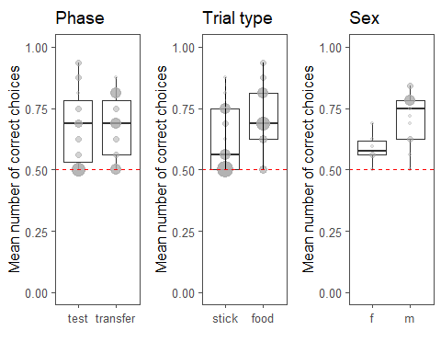

## Test against chance

#### Test and transfer phase

##   
## One Sample t-test  
##   
## data: ripmon_separate$correct[ripmon_separate$phase == "test"]  
## t = 4.9994, df = 18, p-value = 9.296e-05  
## alternative hypothesis: true mean is not equal to 0.5  
## 95 percent confidence interval:  
## 0.6029850 0.7522781  
## sample estimates:  
## mean of x   
## 0.6776316

##   
## One Sample t-test  
##   
## data: ripmon_separate$correct[ripmon_separate$phase == "transfer"]  
## t = 5.9779, df = 18, p-value = 1.179e-05  
## alternative hypothesis: true mean is not equal to 0.5  
## 95 percent confidence interval:  
## 0.6109368 0.7311684  
## sample estimates:  
## mean of x   
## 0.6710526

**Performance is above chance in both Test (last 16 trials) and Transfer phases.**

#### Comparison between test and transfer phase

##   
## Paired t-test  
##   
## data: ripmon_separate$correct[ripmon_separate$phase == "test"] and ripmon_separate$correct[ripmon_separate$phase == "transfer"]  
## t = 0.16705, df = 18, p-value = 0.8692  
## alternative hypothesis: true difference in means is not equal to 0  
## 95 percent confidence interval:  
## -0.07615999 0.08931789  
## sample estimates:  
## mean of the differences   
## 0.006578947

**There is no significant difference between the monkeys' performances in Test and Transfer phases.**

#### Trial type

##   
## One Sample t-test  
##   
## data: ripmon_individual3$foil.correct[ripmon_individual3$trialtype == "food"]  
## t = 6.8461, df = 18, p-value = 2.089e-06  
## alternative hypothesis: true mean is not equal to 0.5  
## 95 percent confidence interval:  
## 0.6527602 0.7880293  
## sample estimates:  
## mean of x   
## 0.7203947

##   
## One Sample t-test  
##   
## data: ripmon_individual3$foil.correct[ripmon_individual3$trialtype == "stick"]  
## t = 4.5067, df = 18, p-value = 0.000273  
## alternative hypothesis: true mean is not equal to 0.5  
## 95 percent confidence interval:  
## 0.5684834 0.6880955  
## sample estimates:  
## mean of x   
## 0.6282895

#### Comparison between food-stick, stick-food trials

##   
## Paired t-test  
##   
## data: ripmon_individual3$foil.correct[ripmon_individual3$trialtype == and ripmon_individual3$foil.correct[ripmon_individual3$trialtype == "food"] and "stick"]  
## t = 2.8, df = 18, p-value = 0.01184  
## alternative hypothesis: true difference in means is not equal to 0  
## 95 percent confidence interval:  
## 0.02299599 0.16121454  
## sample estimates:  
## mean of the differences   
## 0.09210526

**There is a significant difference between performances in different trial types: Monkeys performed better in food-stick trials than in stick-food trials.**

#### Sex

##   
## One Sample t-test  
##   
## data: ripmon_individual4$foil.correct[ripmon_individual4$sex == "m"]  
## t = 7.1835, df = 12, p-value = 1.112e-05  
## alternative hypothesis: true mean is not equal to 0.5  
## 95 percent confidence interval:  
## 0.6490519 0.7788328  
## sample estimates:  
## mean of x   
## 0.7139423

##   
## One Sample t-test  
##   
## data: ripmon_individual4$foil.correct[ripmon_individual4$sex == "f"]  
## t = 3.4, df = 5, p-value = 0.01925  
## alternative hypothesis: true mean is not equal to 0.5  
## 95 percent confidence interval:  
## 0.5215994 0.6554839  
## sample estimates:  
## mean of x   
## 0.5885417

#### Comparison between males and females

##   
## Welch Two Sample t-test  
##   
## data: ripmon_individual4$foil.correct[ripmon_individual4$sex == "m"] and ripmon_individual4$foil.correct[ripmon_individual4$sex == "f"]  
## t = 3.1697, df = 15.549, p-value = 0.006117  
## alternative hypothesis: true difference in means is not equal to 0  
## 95 percent confidence interval:  
## 0.04133463 0.20946665  
## sample estimates:  
## mean of x mean of y   
## 0.7139423 0.5885417

**Males performed significantly better than females.**

## First trial performance in Transfer phase

#### Is the performance above chance in first trial of Transfer?

##   
## One Sample t-test  
##   
## data: ripmon_1st_trial$correct  
## t = -0.22361, df = 18, p-value = 0.8256  
## alternative hypothesis: true mean is not equal to 0.5  
## 95 percent confidence interval:  
## 0.2264313 0.7209371  
## sample estimates:  
## mean of x   
## 0.4736842

**No, performance in the first trial of transfer does not differ from chance level.**

## How about the first 8 trials of Test phase (to be able to compare to children)?

## Performance against chance in the first 8 trials of the test phase:

##   
## One Sample t-test  
##   
## data: ripmon_test8$correct  
## t = 0.97316, df = 151, p-value = 0.332  
## alternative hypothesis: true mean is not equal to 0.5  
## 95 percent confidence interval:  
## 0.4593305 0.6196169  
## sample estimates:  
## mean of x   
## 0.5394737

**They are at chance level in the first 8 trials of Test (for comparison purposes with children).**